No ProbLlama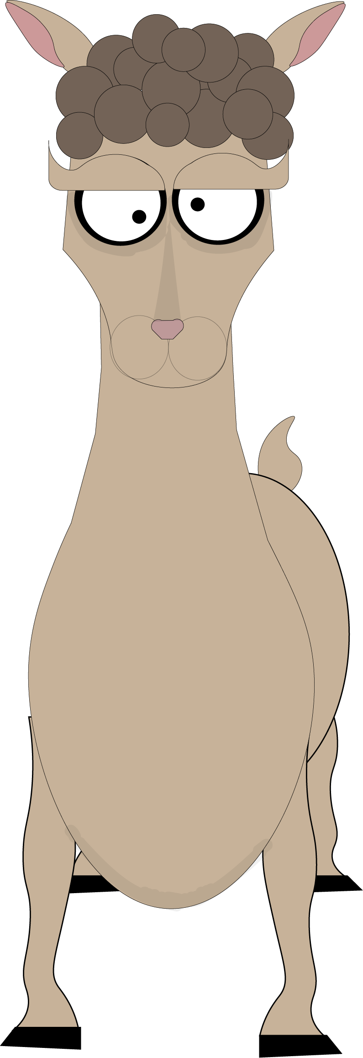

A Video Game by: Robert Dunlap, Charlie Steinmetz, Matthew Brendlinger, Elisa Ambrose, Brandon Pugh, and Dominic Petrillo

Scrum Master: Robert Dunlap

Trello: https://trello.com/b/yGMs0ZmD/rpg-arcade-game

GitHub Repository: <https://github.com/BrandonPugh5/SeniorProject#seniorproject>

Slack Channel: <https://seniorprojectgame.slack.com/>

**Project Summary**

No ProbLlama is a 2-Dimensional video game built in the Unity Engine in C#. This game revolves around a main character, who is a farm girl, that one day finds a ray gun that fell from a dimensional portal in the sky. After finding this gun, she decides to test it out on her pet llama, and her llama shrinks down to the size of a cat. After she realizes that she’s found a truly powerful alien weapon, a portal appears below her feet and she is transported to a new dimension. In this dimension, she has to use her newly acquired weapon to solve a variety of puzzles and defeat bosses in different dimensions to return home. The player has a choice of which dimension to go to, and each time you play, the dimensions have different layouts. By exploring the different dimensions, you learn about the lore of the dimensions and find out about why you’ve been transported here. In order to guide you, your ray gun can talk! He explains how he works.

**Project Goal**

The goal of No ProbLlama is to challenge our skills as Computer Science Majors by designing a game that will show off our abilities to create changing environments, character creation, animations, and dynamic challenges depending on character ability. This project will also demonstrate our ability to self teach and work in a group setting where all aspects must be agreed upon. Our group must also hold to specific deadlines set in place for us which will demonstrate time management.

**Project Features**

Players will be assisted by a llama companion

* Companion lends players new abilities
* Companion offers new ways to traverse levels

Traverse new dimensions each with their own visual style

Effects of shrink rays include:

* where player changes the mass of objects with the shrink ray to change their buoyancy and complete puzzles
* where player uses the shrink ray to give objects velocity on ice while the objects are small and then increase their size to destroy other objects to complete puzzles
* Where player uses shrink ray to get to different areas/ move things

Procedurally generated stages

* Stages have branching paths
* Stages have multiple solutions which are completable using the same shrink ray power

Original Art

* Original 2D characters
* Original animations

Intelligent Tutorials

* Players are taught through subtle hints and examples rather than being told directly.

Bosses made with Artificial Intelligence

Player basic abilities:

* Walk/run
* Shoot gun
* Jump
* Aim gun

Gun powers:

* Shrinking/small
* Growing/big
* Antigravity/float
* Tractor beam/move things
* Reverse gravity/stick to ceilings
* Time slow/go faster

Llama Powers

* Double Jump
* Wall climbing

**Project limitations**

We are limiting ourselves to using Unity and C#.

None of us have any major experience with creating the models and art for the game.

None of us have built a game of this nature before, so Spikes will be necessary to learn about developing games like this.

Cut scene animations won't look professional.

**Stretch goals**

Try to get the game on multiple platforms besides just PC.

Create a meaningful backstory for why everything is happening.